Robert Minson

March 2, 2023

SYM-408

Prof. Dilts

Extract Transform Load (ETL) Process

Query statement pulling all the rows and columns

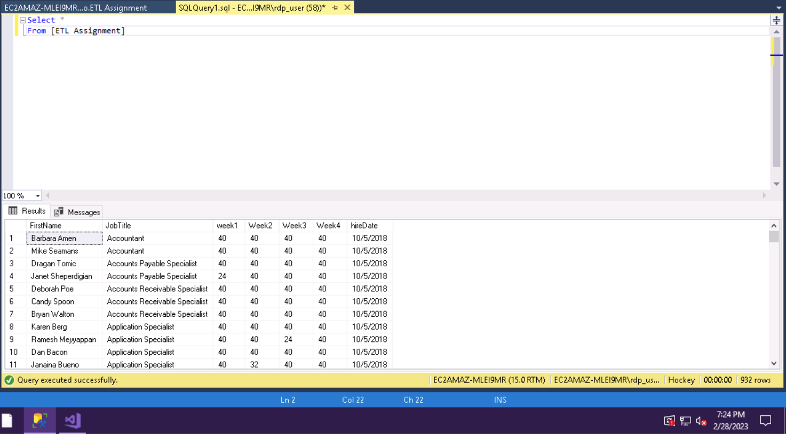

Query statement pulling all files where week 4 was less than 40

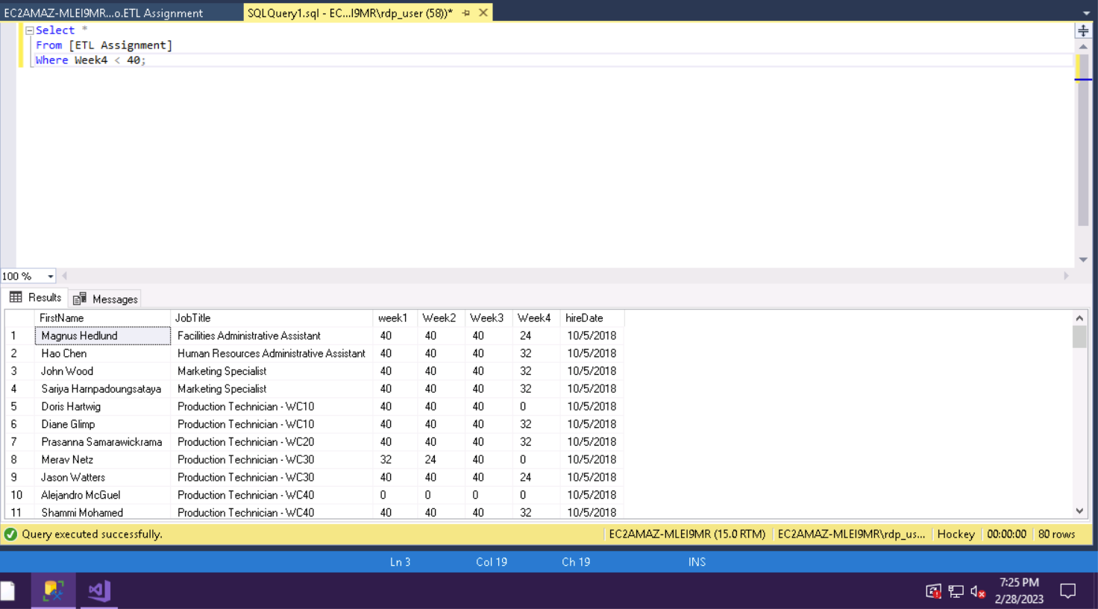

Within SSIS, SQL Server Integration Services, there are data flow components, data location differences, data transformation tools, BI/OLAP tools, and different optimization techniques. Two of the data flow components include sources and destinations. Sources are the incoming data to get transformed and destinations are the places that newly morphed data goes. There are two main differences in data location comes down to if it is a relational or multidimensional database. In a relational database there is only a 2D dimension to work with storing data in a multidimensional one however, possibilities can expand into 4D allowing for more data and quicker speed (Rafter, 2020). Data transformation tools are plentiful but can be broken down into a few categories, those are business intelligence, row, rowset, split and join, and auditing transformations, all with two or more specific tools to accomplish the categories’ broader goal (Microsoft, 2023a). The main tool that SSIS has for its OLAP needs is Microsoft OLAP data cubes. It allows for the publishing, viewing, and manipulating of data via Excel or SharePoint (Microsoft, 2023b). Finally, there are a whole host of different ways to optimize SSIS in terms of data flow. You can target the reading, transforming, or writing data performance by using no less then three different techniques for each as well as universal data flow optimization techniques and control flow techniques (Verbeeck, n.d). SQL Server Integration Services, or SSIS, has a lot of different moving parts from its data flow components to optimization techniques and all of them have their purpose in it.

References

Rafter, B. (2020 October, 26). *Relational vs. multidimensional databases why SQL can impair your analytics.* Retrieved from https://www.inzata.com/relational-vs-multidimensional- databases-why-sql-can-impair-your-analytics/

Microsoft. (2023a, February 28). *Integration Services Transformations.* Retrieved from https://learn.microsoft.com/en-us/sql/integration-services/data-flow/transformations/integration-services-transformations?view=sql-server-ver16.

Microsoft. (2023b, February 15). *Overview of service manager OLAP cubes for advanced analytics.* Retrieved from https://learn.microsoft.com/en-us/system-center/scsm/olap- cubes-overview?view=sc-sm-2022

Verbeeck, K. (n.d). *SQL server integration services SSIS performance tuning techniques.* Retrieved from https://www.mssqltips.com/sqlservertutorial/9070/sql-server-integration-services-ssis-performance-tuning-techniques/.